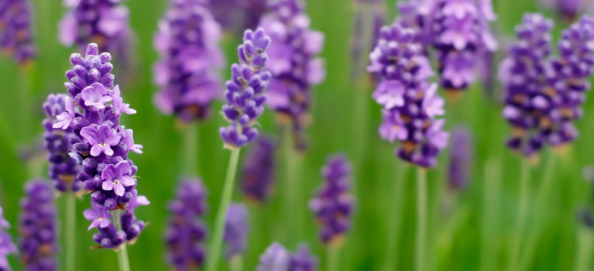

Lavender Uses
Massage Oil Blend
For a relaxing massage try this blend:
- 1 oz of a base oil (like sweet almond oil or coconut oil)
- 3 drops of Lavender Essential Oil
- 3 drops of Lemon Essential Oil
- *for this remedy, dilute and test a little of the oil on your hand to ensure no unknown skin sensitivity exists
*do not touch to eyes, wash hands after use
Bath Oil Blend
For a calming bath oil, combine 2 cups of sweet almond oil, 10 drops of Lavender Essential Oil, 10 drops of Orange Essential Oil, and 10 drops of Geranium Essential Oil. Keep in a re-sealable container.
To use: add 1 teaspoon of the mix to a bath, and relax
Source: lorannoils.com

