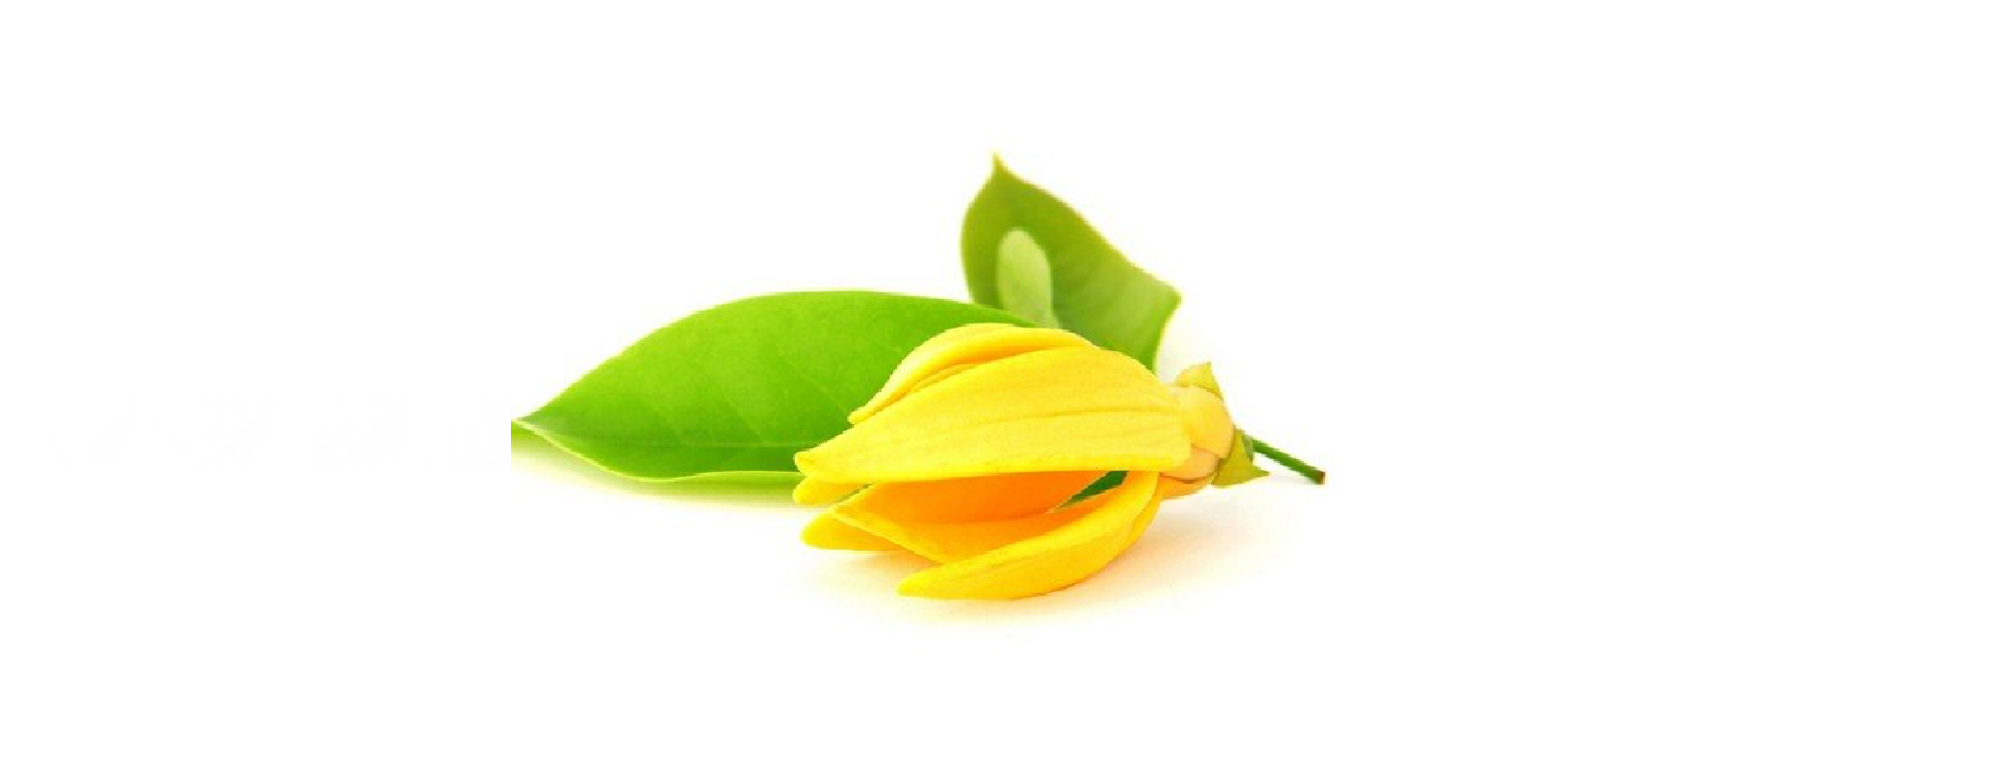

YLANG YLANG USES
Bath
Add into an Epsom Salt bath for a relaxing fragrance
Perfume
Dab a few drops on your wrists for an easy flower perfume.
- for this remedy, dilute and test a little of the oil on your hand to ensure no unknown skin sensitivity exists
*do not touch to eyes, wash hands after use
Joyful Diffuser Blend
- 2 drops Bergamot Essential Oil
- 2 drops Grapefruit Essential Oil
- 1 drop Ylang Ylang Essential Oil
Sources: pinterest.com and doterra.com

