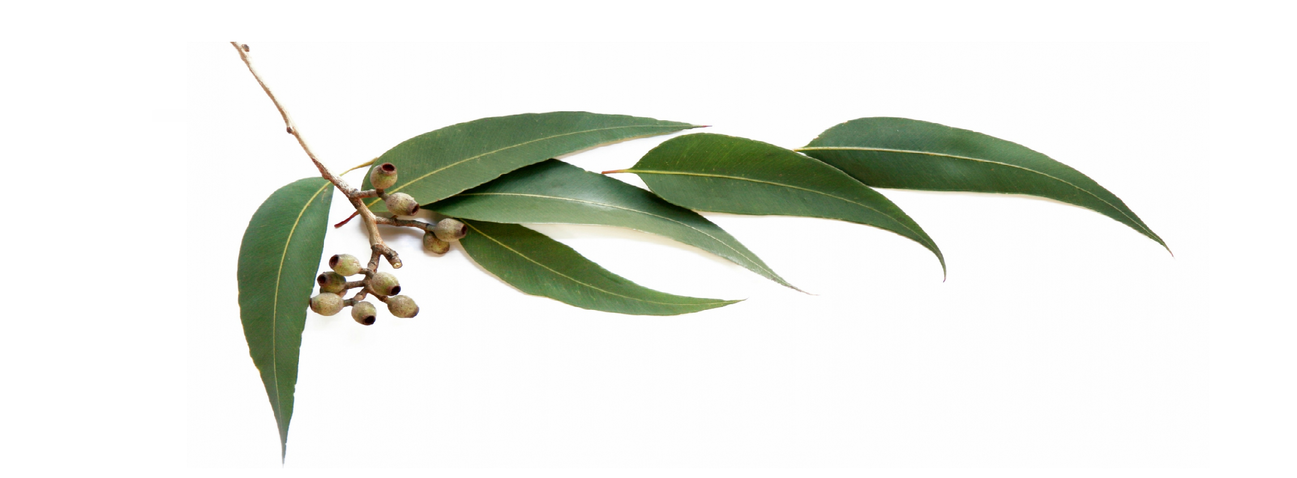

Eucalyptus Uses
Muscle Aches
Apply 1-2 drops to coconut oil and rub on the affected area.
- for this remedy, dilute and test a little of the oil on your hand to ensure no unknown skin sensitivity exists
*do not touch to eyes, wash hands after use
Frozen Relaxation Towels
In a container, stir 10 drops of Eucalyptus with 3 cups of water (these numbers can change depending on how many towels you want). Submerge a washcloth, one at a time, and then ring out excess liquid. Be sure to keep some liquid in the cloth though. Then fold in half and roll up. Place on a cookie sheet and then put them in the freezer. It may take a few hours for them to freeze, but once they do you will have access to immediate cool, soothing relief. These work best when they are applied to the neck/shoulders. Forehead would also work, being careful not to get it into your eyes.
Sources: doterra.com and simplydarrling.com

